

ROLL NO.: 241801281

NAME: SUJITHA NEELAKANDAN VIGNESHWARI

WEEK 04-02 PRACTICE SESSION

1.OBJECTIVE:

A set of N numbers (separated by one space) is passed as input to the program. The program must identify the count of numbers where the number is odd number

CODE:

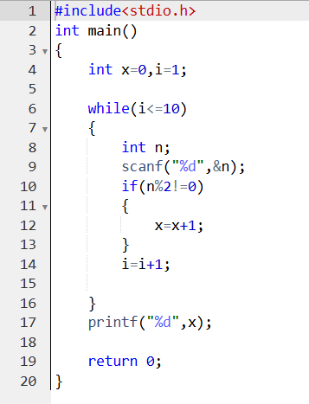

OUTPUT:

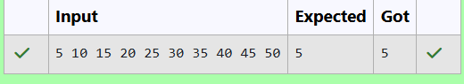

2.OBJECTIVE:

We can rotate digits by 180 degrees to form new digits. When 0, 1, 6, 8, 9 are rotated 180 degrees, they become 0, 1, 9, 8, 6 respectively. When 2, 3, 4, 5 and 7 are rotated 180 degrees, they become invalid. A confusing number is a number that when rotated 180 degrees becomes a different number with each digit valid.

CODE:

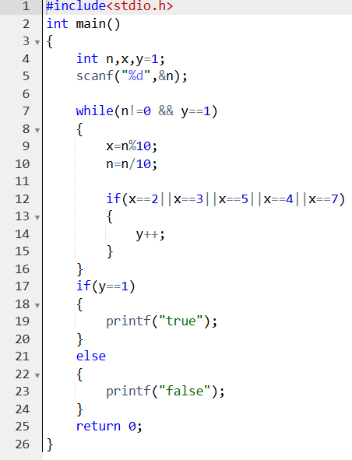

OUTPUT:

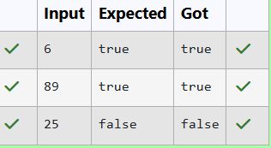

3.OBJECTIVE:

Compute the highest total of macronutrients that can be prescribed to a patient, without the sum matching the given 'unhealthy' number.

CODE:

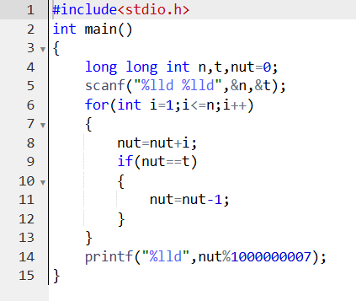

OUTPUT:

